Will Koester
Arctic Ecology Mass Media Science Magazine Article

Seals and Arctic Climate Change: How receding sea-ice is affecting Arctic seal populations. By Will Koester

While the causes for climate change and the degree to which humans are affecting it are still being debated, the current trend of rising temperatures is very real and is having negative effects on the amount of Arctic sea-ice that can form each year, as well as how early it can form. This lack of sea-ice has had adverse effects on much of the Arctic’s biotic populations, and in particular has made life more difficult for seals. By examining the lifestyles and habits of the four ice dependent seal species in the Arctic, the overall health of the seal population of the Arctic can be judged. Being at an upper-middle trophic level, seals are an excellent indicator of how healthy the ecosystem is as a whole, and how drastically, or not, climate change is affecting the Arctic.
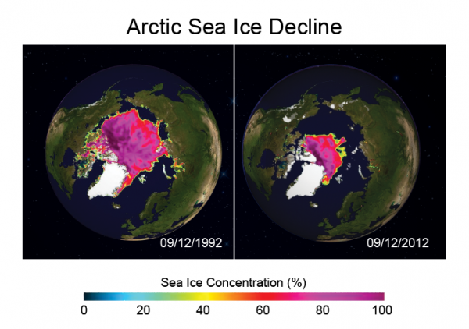
Before we can look at seals individually, a holistic understanding of how climate change is affecting a variety of Arctic wildlife will help us to contextualize the changed circumstances that seals are facing. The Arctic is an environment of increasing change due to clime warming and the effects of persistent human presence. Some of the climatic developments that Arctic wildlife have had to adapt to recently include loss of sea ice, and faltering nutrient availability. The effects of physical drivers such as temperature increases and increased levels of greenhouse gases have led to both immediate primary responses as well as longer term more diffuse climatic responses. Of all the Arctic’s responses to climate change, sea ice loss is unquestionably the worst for seal populations, it also has a negative effect on the Artic as a whole. Positive ice-albedo feedback continues to make sea-ice break up occur sooner, and for recurrent ice to be thinner each year. Sea-ice loss has amounted to around 3%-10% of total ice volume each decade since 1979, additionally, sea ice has been exposed to a progressively increasing number of thaw days per year in a trend going back to the early 1900’s. Loss of sea ice serves to decrease the quality and availability of food for ice dwelling mammals as well as shrinking their habitat. The interconnected nature of the Arctic makes changes to such a ubiquitous and important part of the ecosystem as sea-ice have far reaching consequences that effect not only seal behavior and range, but their predator and prey species. By examining how seals respond to climate change, a clearer picture of how the Arctic as a whole responds to climate change can be formed, as well as clearer predictions about seal’s futures.

Figure 1 Arctic sea-ice concentration decline over time

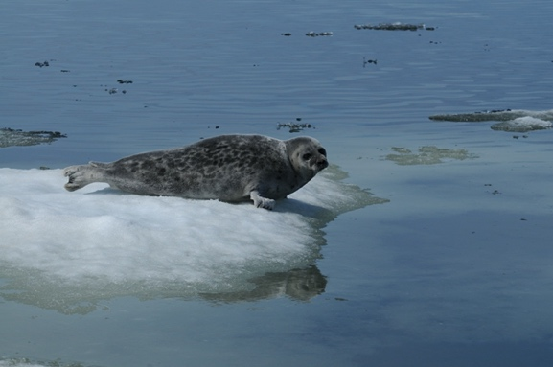
Of all the seals in the Arctic, Ringed seals are the most common and widespread species and number in the millions. As with all ice-dependent seals, sea-ice loss has hurt this species, however, the consequences of sea-ice loss have been direr for Ringed seals than other species, due to the Ringed seal’s natural habit of creating holes and dens in ice and snow where they both rest and raise their young. This requires thick and stable ice, which has been steadily disappearing. As far as their hunting practices go, Ringed seals prefer small fish, such as Polar cod, which is found around sea-ice edges. With increased ice melt, Ringed seals have been forced to feed more upon invertebrates during open water seasons as sea-ice hunting grounds have decreased in number. Ringed seals are nearly completely dependent on sea ice and are rarely seen hauled out on land. Though they have the largest population in the Arctic, sea-ice loss is hitting the Ringed seals the hardest.
An adorable example of the most common seal in the Arctic, the Ringed seal

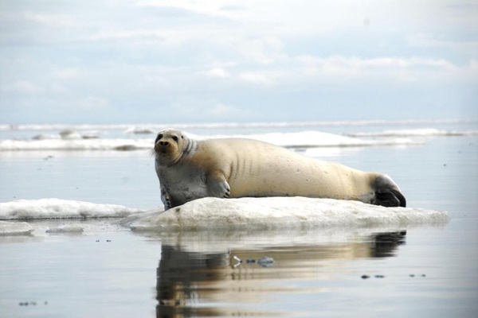
In contrast to the Ringed Seal, Bearded seals are sometimes seen on land and don’t require burrows to birth and raise their young. The largest seals in the Arctic, Bearded seals are benthic feeders and live in shallower water on the edge of sea ice as well as on land-fast ice; their name coming from the whiskers which help them detect food on the sea floor.
Their preference for shallower waters closer to land, as well as their willingness to haul out on land puts them in a better position to adapt to decreasing amounts of sea-ice than Ringed seals. Additionally, Bearded seal pups are capable of swimming and diving to 200 feet deep within a week of birth, affording the pups more freedom to find suitable sea-ice.
A Bearded seal hauled out on sea-ice

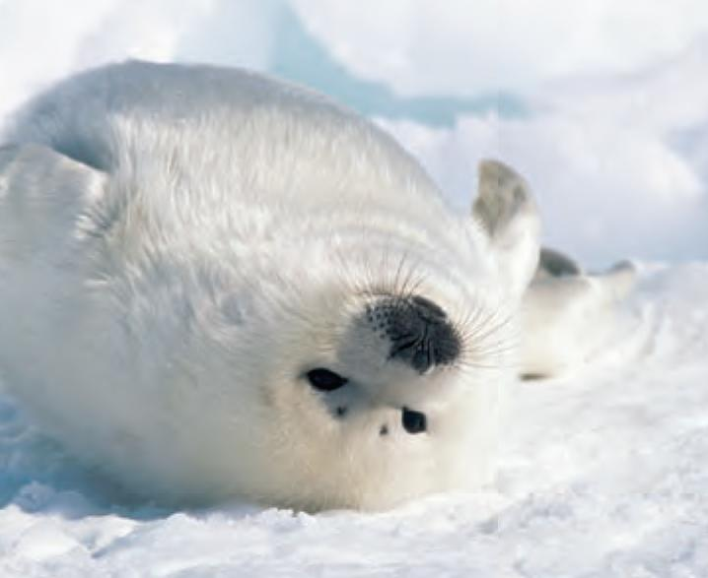
While they produce some of the cutest pups of any animal on Earth, Harp seals are also at major risk due to sea ice loss. In particular, the breeding habits of the species makes them very sensitive to ice melt. Harp seals tend to congregate in southern sea-ice breeding sites off of Canada in the west and the White sea in the east at consistent times each year in the early spring. Though breeding in varying locations provides some protection from sea-ice melt, Harp seals make very specific choices about the type of ice they breed upon, seasonally formed drifting pack ice, and have a remarkably specific window for mating, making any shift in the timing of ice melt result in fewer births later in the year. Additionally, Harp seal pups are dependent on sea-ice, and nearly 100% pup mortality has been reported when early ice melt occurs, such as reported in 2007 when ice conditions resulted in little to no sea-ice for the pups to rest and be fed on. Harp seals are also at elevated risk due to ship collisions on ice as they spend much of their lives drifting on sea ice.
An playful Harp seal pup

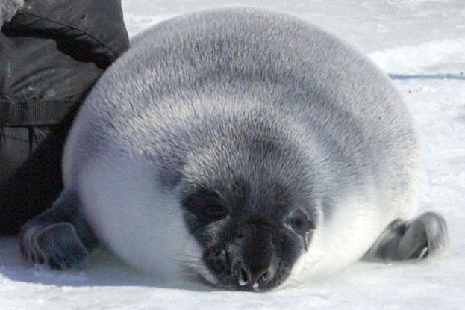
In contrast to other ice-dependent seal species, hooded seals are more pelagic than the other seal species in the arctic, often moving around with drifting pack ice on an annular time scale. Hooded seals are versatile feeders and prefer to feed at depth, eating deep-water fish such as halibut and redfish, Hooded seals even go deep enough to capture squid. Satellite tracking has shown Hooded seal activity along continental shelf edges which allows them to take advantage of deeper waters as well as the nutrient rich waters caused by upwelling, providing good hunting grounds. Hooded seals are much more solitary and territorial than other seal species and confrontations between males over mates are frequent and often decided by the namesake “hood” which the seals possess. A unique adaptation for these seals, they can inflate a pouch of skin on their noses in a display of dominance to settle conflicts and impress females, thus avoiding physical conflict. Hooded seals are also susceptible to early sea ice melt in much the same way as Harp seals due to having very specific late-spring breeding times, as well as requiring heavier multi-year ice to both breed and haul out in order to accommodate their greater weight.
A Hooded seal hauled out on pack ice

While these are the four sea-ice dependent Arctic seal species, there are two other non-ice dependent seal species: Ribbon and Spotted seals. They each live exclusively in northern Pacific, Chukchi Sea and Bering Strait waters, typically closer to the coastal areas. The Ribbon seal spends much more time in the open ocean than other Arctic seals, including while hunting, and during seasonal roaming. Spotted seals are also less susceptible to sea ice loss as they spend much more time hauled out on land and only come out to sea-ice to forage if food isn’t available closer to shore. The diverse range of seal species that occupy the Arctic means that there will be variable responses to the challenges posed by climate change, with some handing the change better than others.

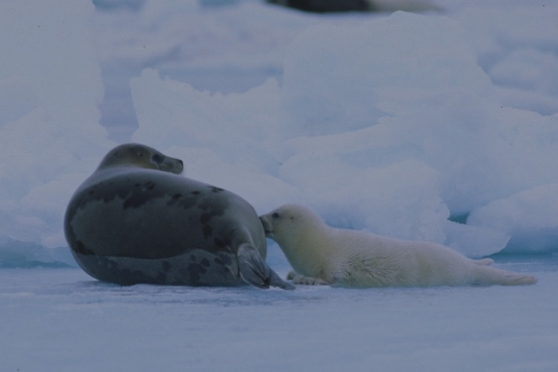
With the most damaging effect of warming temperature trends in the Arctic being the early or total loss of sea-ice which supports, to at least some extent, all of the six species of seal present in the Arctic, there are many obstacles seal are having to figure out how to overcome. The range of problems Arctic seals have had to deal with includes finding suitable breeding and nursing locations, dealing with general habitat loss as well as hunting and diet changes. When it comes to the general seal reproductive cycle, seals usually spend much of the year following pack ice and moving throughout the Arctic, particularly Ringed seals, who have a large circumpolar range; once spring arrives seals congregate in predictable locations on sea-ice in order to mate, molt and go back to sea. However, in years when sea-ice has melted earlier in the spring, seals have not been able to find suitable breeding grounds, leading to a lower number of pups birthed. Once the pups are born, in addition to being incredibly cute, they need to put on weight fast in order to survive the Arctic cold, as well as to be ready to learn to swim. Most seal lactation periods take place over the course of weeks with pup weight ranging from as little as 4kg (Ringed seal) and as much as 37kg (Bearded seal). While adaptations such as short lactation periods (Hooded seal) and the ability for pups to swim early (Bearded seal) help to reduce pup dependence on ample sea-ice for rest and feeding, the decline or absence of sea-ice has led to increasing pup mortality and population loss in recent years. Earlier sea-ice melt is forcing all seal species to summer farther north than in the past due to earlier spring breakups of ice and less southern Arctic ice to support hunting and haul-outs. Additionally, heavier seals such as Bearded and Hooded seals who prefer multi-year ice, which is getting progressively rarer, are having more trouble finding suitable ice to breed and rest upon. As an example of this problem of seals being forced to go farther north, while tracking Ringed seal specimens, it was found that they were more than 2 times as likely to be found in areas of high (80%-100%) sea-ice coverage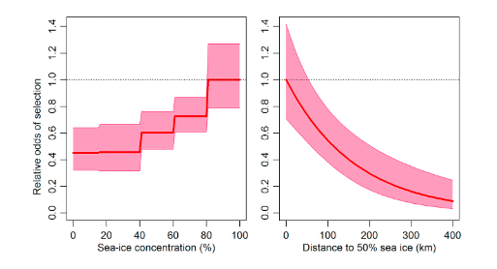
A Harp seal and her pup feeding on sea-ice
Figure 2 Graphs showing the likelihood of encountering a Ringed seal given sea-ice conditions
than low (0%-40%). This shows how seals are being forced to stay close to ever receding sea-ice and are having to depend on less habitat area, being pushed farther north to find higher ice concentrations. Additionally, the nutrients available and the quality of seal hunting grounds has also decreased as drifting sea ice has disappeared. In a study done in the Hudson Bay, seals were caught by subsistence hunting natives and samples were taken of seal muscle and fat tissue. When measuring N-15 stable isotopes, which serve as markers for nitrogen based nutrients in seal muscle tissue, it was found that ringed seals had 13.4 ppt (parts per thousand) and Bearded seals had 15.4 ppt, showing a baseline for nutrient needs of seal muscle tissue. As Bearded and Ringed seals age, their nutrient demands changed, with Ringed seals requiring more N-15, whereas Bearded seals had progressively less N-15 showing in their bodies over their life spans. The different isotope levels in the two seals also reflects the differing diets of the two, Ringed seals eating fish and Bearded seals feeding on benthos. The dietary needs of seals furthermore differ among different age classes of seals ranging from pup to adult, with species such as the Bearded seal not having to increase the proportion of nutrients such as Nitrogen and Carbon to their body weight as they grow, whereas Ringed seals do need to have proportionally more nutrients as they grown. The continued need for diverse nutrient and food intake is putting stress on seals who can’t access Benthos for feeding as well as the more pelagic species, such as the Ringed seal who doesn’t have as much sea-ice to hunt off of. In addition to facing their own struggles, the effects of declining seal numbers on the Arctic ecosystem could also end up being quite harmful. With declining seal numbers, the implications of removing a mid-level predator of fish, and more importantly benthos, would slow benthic-pelagic exchange, as well as deprive polar bears and foxes of their prey; furthermore, fish numbers could grow unchecked and lead to a decrease in planktons and other invertebrates due to unchecked predation, further depriving the Arctic of nutrients.

Seal species populations currently number in the hundreds of thousands, and even the low millions, the future of Artic seals isn’t in immediate danger, it is however, exhibiting a trend of worsening conditions, and if sea-ice loss and warming temperatures continue to occur, then seals could lose their breeding and hunting environments and struggle to carry on. The broader implications of losing seals are that predation of fish and benthos can fall off and prey for species such as polar bears will disappear, leading to their own struggles. Additionally, indigenous peoples would lose a primary food source and there would be a major gap in the food chain which would lead to difficulties in nutrient cycling and energy sharing within the ecosystem. Figuring out how we can combat the loss of seal habitat, as well as creating a more complete accounting of the adverse effects of climate change seals are facing will help to better moderate the negative impacts of climate change, but it is abundantly clear that sea-ice loss is negatively impacting seal populations and the health of the Arctic as a whole.

References & Endnotes

Burek, K.A., Gulland, F.M.D., O’Hara, T.M. Effects of Climate Change on Arctic Marine Mammal Health. Ecological Applications 18, 126-134 (2008). https://www.jstor.org/stable/40062160

Hermert, C.V., Fline, P.K., Udevitz, M.S., Koch, J.C., Atwood, T.C., Oakley, K.L., Pearce, J.M. Forecasting Wildlife Response to Rapid Warming in the Alaskan Arctic. BioScience 65, 718-728 (2015). https://doi.org/10.1093/biosci/biv069

Huntington, H.P. Treating Arctic ecosystems as systems. Environment 59, 24-40 (2017). https://doi.org/10.1080/00139157.2017.1325302

Karen, L., Hamilton, C.D., Aars, J., Lydersen, C., Kovacs, K.M. Summer habitat selection by Ringed seals (Pusa Hispida) in the drifting sea ice of the northern Barents Sea. Polar Research 38, 1-10 (2019). https://doi.org/10.33265/polar.v38.3483

Kovacs, K.M., Lydersen C. Climate change impacts on seals and whales in the north Atlantic Artic and adjacent shelf seas. Science Progress 91, 117-150 (2008). http://dx.doi.org/10.3184/003685008X324010

Lomac-MacNair, K., Jakobsson, M., Mix, A., Freire, F., Hogan, K., Mayer, L., Smultea, M.A. Seal Occurrence and Habitat Use During Summer in Petermann Fjord, Northwestern Greenland. Arctic 71, 334-348 (2018). https://doi.org/10.14430/arctic4735

Young, B.G., Loseto, L.L., Ferguson, S.H. Diet Differences Among Age Classes of Arctic Seals: Evidence From Stable Isotope and Mercury Biomarkers. Polar Biology 33, 153-162 (2010). https://doi.org/10.1007/s00300-009-0693-3

Hermert, C.V., Fline, P.K., Udevitz, M.S., Koch, J.C., Atwood, T.C., Oakley, K.L., Pearce, J.M. Forecasting Wildlife Response to Rapid Warming in the Alaskan Arctic. BioScience 65, 718-728 (2015). https://doi.org/10.1093/biosci/biv069
Hermert, C.V., Fline, P.K., Udevitz, M.S., Koch, J.C., Atwood, T.C., Oakley, K.L., Pearce, J.M. Forecasting Wildlife Response to Rapid Warming in the Alaskan Arctic. BioScience 65, 718-728 (2015). https://doi.org/10.1093/biosci/biv069
Burek, K.A., Gulland, F.M.D., O’Hara, T.M. Effects of Climate Change on Arctic Marine Mammal Health. Ecological Applications 18, 126-134 (2008). https://www.jstor.org/stable/40062160
Kovacs, K.M., Lydersen C. Climate change impacts on seals and whales in the north Atlantic Artic and adjacent shelf seas. Science Progress 91, 117-150 (2008). http://dx.doi.org/10.3184/003685008X324010
National Oceanic and Atmospheric Administration. (2019, September 24). Ringed Seal. NOAA Fisheries. https://www.fisheries.noaa.gov/species/ringed-seal
Kovacs, K.M., Lydersen C. Climate change impacts on seals and whales in the north Atlantic Artic and adjacent shelf seas. Science Progress 91, 117-150 (2008). http://dx.doi.org/10.3184/003685008X324010
National Oceanic and Atmospheric Administration. (2019, Septemer 24). Bearded Seal. NOAA Fisheries. https://www.fisheries.noaa.gov/species/bearded-seal
National Oceanic and Atmospheric Administration. (2019, September 24). Harp Seal. NOAA Fisheries. https://www.fisheries.noaa.gov/species/harp-seal
Kovacs, K.M., Lydersen C. Climate change impacts on seals and whales in the north Atlantic Artic and adjacent shelf seas. Science Progress 91, 117-150 (2008). http://dx.doi.org/10.3184/003685008X324010
Huntington, H.P. Treating Arctic ecosystems as systems. Environment 59, 24-40 (2017). https://doi.org/10.1080/00139157.2017.1325302
National Oceanic and Atmospheric Administration. (2019, September 24). Hooded Seal. NOAA Fisheries. https://www.fisheries.noaa.gov/species/hooded-seal
Kovacs, K.M., Lydersen C. Climate change impacts on seals and whales in the north Atlantic Artic and adjacent shelf seas. Science Progress 91, 117-150 (2008). http://dx.doi.org/10.3184/003685008X324010
Kovacs, K.M., Lydersen C. Climate change impacts on seals and whales in the north Atlantic Artic and adjacent shelf seas. Science Progress 91, 117-150 (2008). http://dx.doi.org/10.3184/003685008X324010
Lomac-MacNair, K., Jakobsson, M., Mix, A., Freire, F., Hogan, K., Mayer, L., Smultea, M.A. Seal Occurrence and Habitat Use During Summer in Petermann Fjord, Northwestern Greenland. Arctic 71, 334-348 (2018). https://doi.org/10.14430/arctic4735
National Oceanic and Atmospheric Administration. (2019, September 24). Ribbon Seal. NOAA Fisheries. https://www.fisheries.noaa.gov/species/ribbon-seal
Kovacs, K.M., Lydersen C. Climate change impacts on seals and whales in the north Atlantic Artic and adjacent shelf seas. Science Progress 91, 117-150 (2008). http://dx.doi.org/10.3184/003685008X324010
Karen, L., Hamilton, C.D., Aars, J., Lydersen, C., Kovacs, K.M. Summer habitat selection by Ringed seals (Pusa Hispida) in the drifting sea ice of the northern Barents Sea. Polar Research 38, 1-10 (2019). https://doi.org/10.33265/polar.v38.3483
Young, B.G., Loseto, L.L., Ferguson, S.H. Diet Differences Among Age Classes of Arctic Seals: Evidence From Stable Isotope and Mercury Biomarkers. Polar Biology 33, 153-162 (2010). https://doi.org/10.1007/s00300-009-0693-3
Young, B.G., Loseto, L.L., Ferguson, S.H. Diet Differences Among Age Classes of Arctic Seals: Evidence From Stable Isotope and Mercury Biomarkers. Polar Biology 33, 153-162 (2010). https://doi.org/10.1007/s00300-009-0693-3
Kovacs, K.M., Lydersen C. Climate change impacts on seals and whales in the north Atlantic Artic and adjacent shelf seas. Science Progress 91, 117-150 (2008). http://dx.doi.org/10.3184/003685008X324010 Figures & Photos Figures - U.S. Global Change Research Program (2012), Arctic Sea Ice Decline. https://www.google.com/url?sa=i&url=https%3A%2F%2Fwww.globalchange.gov%2Fbrowse%2Fmultimedia%2Farctic-sea-ice-decline&psig=AOvVaw2ZWTsJ8vvcsx3umuKEBmcQ&ust=1582315742394000&source=images&cd=vfe&ved=0CAIQjRxqFwoTCNDcotD34OcCFQAAAAAdAAAAABAD - Polar research. (2019), Ringed Seal offshore foraging habitat selection. https://polarresearch.net/index.php/polar/article/download/3483/9159/22601 Photos - NOAA (2019), Ringed Seal. https://cdn2.webdamdb.com/1280_YQ0wiKD7mfn1.jpg?1505761440 - NOAA (2019), Bearded Seal. https://cdn2.webdamdb.com/1280_tDhh2nXVqGdN.jpg?1504041071 - NOAA (2019), Harp Seal pup. https://cangeo-media-library.s3.amazonaws.com/s3fs-public/styles/web_article_slider_image/public/images/web_articles/article_images/3127/harp_seal.jpg?itok=S992Rhqw - NOAA (2019), Hooded Seal. https://cdn2.webdamdb.com/1280_oW8uuak4f8b7.jpg?1529875944 - NOAA (2019), Harp seal pup feeding. https://cdn2.webdamdb.com/1280_LgthjT8xkw7i.jpg?1505762347

