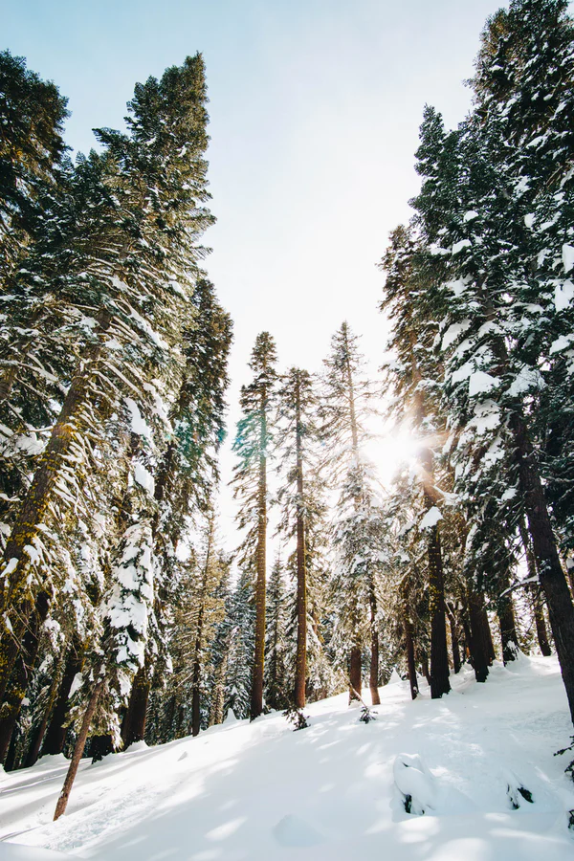

LET IT SNOW
Human impacts and management efforts in the untraversable forest

8
LET IT SNOW
Human impacts and management efforts in the untraversable forest

By CLAIRE WATERHOUSE

Taiga.
What does that word mean to you? To many people, taiga is simply a foreign sounding term–unremarkable, unrelated and unimportant to their daily lives. Stemming from an old Russian root word, taiga roughly translates to “untraversable forest” in the English language. This still leaves people wanting for information. What untraversable forest? Where is it located? Many minds might have come to the preliminary conclusion that this term is in reference to the Amazon rainforest, arguably the most publicly recognized forest on a global scale. Home to many exotic flora and fauna, it is understandable that the Amazon can take the spotlight, overshadowing a much larger giant which rests above the heads of all but the 4 million people that call the Arctic home.
Taiga is most frequently used in Europe as a general term to describe the vast expanse of coniferous forests that encircles the globe at latitudes ranging from 50°N to 70°N. Known more commonly in North America as the boreal forest ecosystem, this expanse of vegetation lies along the border of the Arctic circle. The trees that persist in the boreal region comprise roughly 30% of total forest ecosystems globally.¹ Large swaths of these subarctic forests remain out of the reach of human interference, mainly as a result of the harsh conditions that characterize these regions for 6-8 months out of the year.¹ Flora and fauna that survive in boreal ecosystems must endure long periods of below freezing air and soil temperatures, decreased sunlight, and limited nutrient availability.

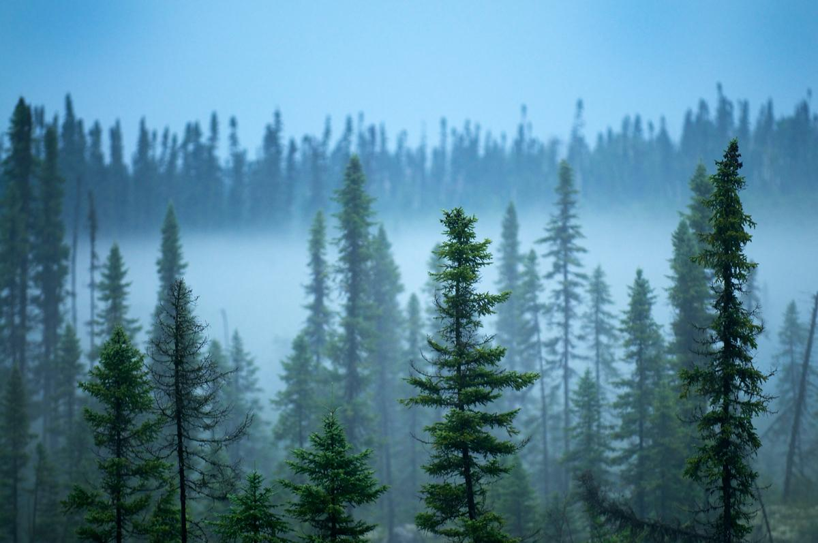
Coniferous trees common in subarctic boreal forests²¹
Although boreal forest systems may be perceived as isolated in their own specific ecological niche by extreme environmental conditions, in reality, they provide major ecosystem services for the rest of the globe. Boreal forests are the site of the largest global source of surface freshwater, about ⅓ of which is stored in permafrost¹‒soil that remains frozen year round. In addition, the large flora biomass plays an important role in carbon cycling, and is estimated to store as much as, if not more, organic carbon than tropical rainforests.¹ Humans also receive tangible benefits of the ecosystem services provided by boreal forests by way of recreational activities such as fishing, hunting and hiking, as well as economic benefits such as logging. An average 33% of the world’s lumber market is accounted for by harvest from boreal forests in northern Canada, Russia and Alaska.¹ Lumber from boreal forests is used to supply and sustain 25% of the global paper making industry.¹ In short, boreal forests provide a range of services pertaining to maintenance of global abiotic processes, as well as ecosystem services which influence a vast array of human activities.

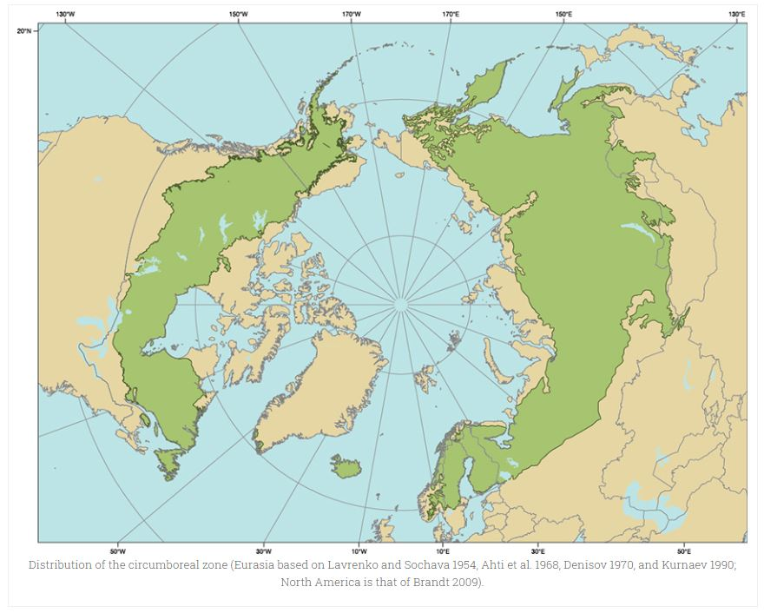Map showing the global distribution of boreal forests¹

As a result of the vast expanse of territory that boreal forests cover in the northern latitudes of major continents, the composition of these forests can vary slightly depending on region. Most of these forests are largely homogeneous due to specific adaptations that are required by flora to survive in extreme environmental conditions.
Scientists cite abiotic factors such as soil composition, surface deposits of minerals and nutrients and water availability as important determinants in the composition of boreal forest flora.² The amount of tree cover can also vary substantially between regions of boreal forests. In most cases, this variation has been shown to be a result of different environmental conditions such as average rainfall, length of the growing season, extent of permafrost, wildfire cycling and temperature fluctuations.³ With this variation coincides the potential for differential responses to changing environments,³ whether by direct and immediate events such as human intervention or more extended processes such as climate change.

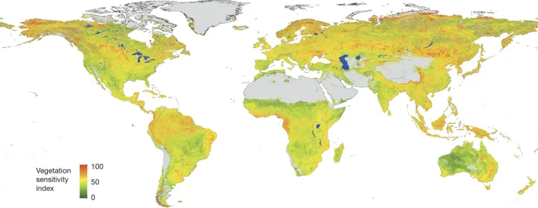
Sensitivity of global vegetation to changes in climate. Areas of high sensitivity are seen in boreal zones as well as tropical regions (colored red on the figure).⁴

The ability of boreal forests to survive in harsh conditions for a large portion of the year does not mean that these ecosystems are not vulnerable to changing environmental conditions. Boreal forests are particularly susceptible to shifts in environmental conditions due to the phenomenon of polar amplification, in which communities adapted to live in unique and extreme environments are more drastically affected by even the slightest change to their ecological system.
Boreal forests are becoming increasingly vulnerable to human exploration as technology for resource extraction continues to advance. What past generations thought of as ‘untraversable’ is becoming more and more accessible to industries and recreational users. Over the past century, data has shown substantial changes in the composition and dynamics of boreal forests. Researchers have noted shifts in species composition of flora and fauna, species richness of boreal communities, rapid permafrost thaw resulting in the creation of wetland habitats and changing animal behavior in response to altered flora composition.⁵
A globally warming climate, which is progressing at two times the rate of the rest of the world in polar regions, could be in part responsible for the observed rapid change in community composition. As the climate in boreal regions becomes less extreme and specific to species native to northern latitudes, it provides temperate species an opportunity to expand into higher and higher latitudes.⁶ Occasionally, these species are even introduced artificially through human intervention.⁶ To escalate the threat that boreal forests face from more naturally occurring processes of climate change, humans are also contributing to the reshaping of these systems through processes such as habitat fragmentation due to logging and land development, pollution and increased resource harvesting.⁵

Human reach into boreal forest ecosystems extends in many different directions. Although not all direct interactions that human populations have with boreal forests have negative consequences, the nature of most of these interactions, particularly involving non-native inhabitants of the Arctic, are detrimental to these ecosystems.
One of the most well researched and accounted for effects that humans have on natural processes of boreal forests is land development. Land development encompasses a wide variety of human activities, such as clearing wooded areas through logging, converting boreal tundra and grasslands into pastures for animals, and clearing and leveling terrain in order to build infrastructure. This often occurs in areas where teams working for the oil industry settle, and can disrupt not only boreal ecosystems, but also natural life and behavioral cycles of flora, fauna and human indigenous communities.
To provide a concrete example, natural fire cycles are very important in maintaining the health and reproductive success of much of the vegetation present in boreal forests. There is variation within the temporal cycles of major fires throughout regions of boreal forests, but in most areas, fires help to maintain forest health by promoting seed germination, clearing away dead vegetation, and providing a new layer of nutrients to renourish boreal soil. Non-indigenous colonization of the Arctic brought a new technology of fire suppression which blossomed into a popular management technique in the 20th century in order to mitigate the potential for fire damage to human infrastructure.⁷ The arrival of coal mining in the Arctic, also during the 20th century, had drastic impacts on fire activity as well. Data from Central Greenland ice cores captured microscopic pollutants that rapidly accumulated in ice sheets due to a coupling of coal mining and fire activity through the late 1900s.⁸ Studies have shown that fire cycles and landscaping of boreal forest systems dramatically affects the vegetative composition of these ecosystems.² This, in turn, can lead to shifts in population dynamics of higher trophic levels.
The arrival of commercial scale animal agriculture and crop production to regions of the subArctic has also taken its toll on boreal forest extension. Studies modeling the largest effectors of ecosystem change in the subArctic found the major culprits to be commercial animal grazing, farming and logging.⁹ Researchers cite “‘repeated human perturbation’” of boreal forest systems to be a more significant factor driving change than shifts in global climate patterns.⁹
Within this vein of commercial animal agriculture lies the husbandry of a regionally specific herbivore‒the reindeer, also known as the caribou in North America. Research presented in the last decade shows a paradoxical decline in reindeer populations with increased vegetation in boreal systems as the growing season of these regions lengthens and becomes warmer.¹⁰ Efforts to maintain reindeer populations, both for conservation and commercial purposes, have persisted for centuries. However, local communities that engage in reindeer husbandry for commercial use typically must face the negative effects brought about by the exploitation of boreal resources. Reindeer husbandry has been shown to impact vegetative productivity, as well as shape the treeline of boreal forests.⁵ Large populations of reindeer have particularly detrimental effects on the growth of woody vegetation such as the willow tree, and have been linked to negative effects on willow populations as well as the community of insect herbivores that rely on the willow for food.¹¹ In recent years, there has also been a growing concern within the scientific community that large scale reindeer herding could have net CO₂ outputs rivaling those of other commercially-raised grazing animals.¹² This research demonstrates that animal husbandry can have far reaching effects outside of those that are directly observed within plant-herbivore relationships.

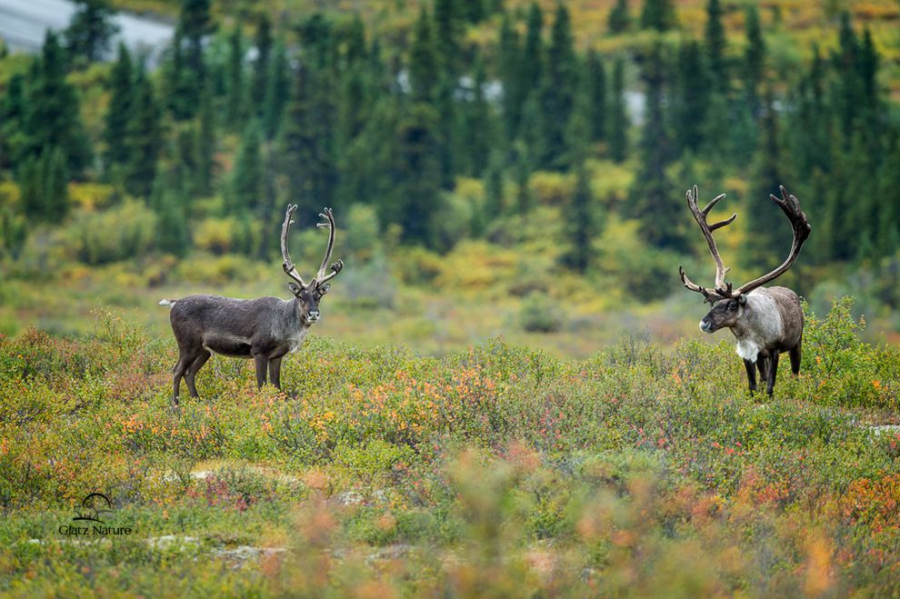
Reindeer, also known as caribou, in their natural habitat¹³

Land used for recreational purposes, a more modern phenomenon, also takes its toll on boreal forest systems. Negative effects of recreational usage are slower to accumulate than those caused by major industries such as logging and farming. However, they can often affect areas of the boreal forest on a localized scale. Recreational hunting, for example, has the potential to deplete the gene pool of a region or deprive indigenous populations of a crucial economic and food resource. A study done on the effect of All-Terrain Vehicles (ATVs) looked at potential effects that paths well-traveled by motorized vehicles could have on soil erosion and nearby vegetation.¹⁴ Results analyzed from three key habitats‒bogs, boreal forests, and heaths‒showed varying degrees of damage, with boreal forests being highly susceptible to off trail vegetative harm.¹⁴

Barraged by changing climate and negative human impacts, it is more important than ever that initiatives to protect and conserve boreal forests be put into motion. Current reports estimate that roughly ⅔ of boreal forest areas are managed to some extent, the majority of this being for the lumber industry.¹⁵⁻¹⁶ As a major resource for natural carbon sequestration that accounts for a minimum 32% of global terrestrial carbon stores,¹⁶⁻¹⁷ scientists are advocating for an increase in management policies to benefit boreal forests.¹⁶
Human shaping of boreal forest landscapes can cause dynamic changes in the structure and composition of vegetation in boreal forests. Changes in regional photosynthesizers, in turn, can significantly impact normal predator-prey interactions of organisms in higher trophic levels of these systems.¹⁸ After witnessing a decrease in some small herbivore and omnivore species due to increased predator performance in areas of cleared land, communities have begun to reintroduce diminishing species to these regions.¹⁸
Humans are particularly focused on the reintroduction of large ungulates–hoofed herbivores–such as reindeer, bison, and elk.¹⁸ With the replenishing of natural populations, conservationists are hopeful that boreal ecosystems will undergo a process of restoration and see a surge in productivity over the subsequent decades after repopulation. One of the most ambitious projects in this vein of conservation science is the formation of Pleistocene Park in the subArctic tundra of Russia. This long-term research endeavor is attempting to ‘geoengineer’ a permafrost layer by converting tundra into what was once a productive steppe grassland.¹⁹ By reintroducing animal species and mimicking growing conditions for vegetation that were present before the steppe was converted to barren tundra, scientists have successfully reintroduced grasslands to this area of subArctic Russia.¹⁹ Grassland provides cover to reduce permafrost melt, which indirectly benefits boreal forest ecosystems by preventing the recession of the treeline due to permafrost melt as well as encroaching tundra.
These rewilding and management initiatives, although conceptually unproblematic to institute, represent a plague for national governments and international corporations who view boreal forest systems as exploitable resources. Conservationists worldwide are calling for the cooperation of the scientific community and indigenous populations to work together to fight for policies that advocate for the protection and proper management of boreal forests in order to ensure the health of these large interconnected ecosystems for the years to come. By promoting a return to more natural and ecologically sustainable levels of resource harvesting, humans can help to mitigate negative impacts to boreal forests, so that these systems in turn can help to mitigate the negative effects of climate change that human communities are experiencing at an increasing frequency. In order to continue to ‘let it snow’ and ensure the persistence of other natural processes in boreal forests, these systems require the implementation of collaborative management strategies in the near future.
1. About Boreal Forests. International Boreal Forest Research Association (1991).
2. Gauthier, Sylvie, De Grandpre, Louis, & Bergeron, Yves. Differences in forest composition in two boreal forest ecoregions of Quebec. Journal of Vegetative Science, 11, 781-790 (2000).
3. Abis, Beniamino, and Victor Brovkin. Environmental Conditions for Alternative Tree-Cover States in High Latitudes. Biogeosciences, 14(3), 511-527 (2017)
4. Seddon, Alistair W. R., et al. Sensitivity of Global Terrestrial Ecosystems to Climate Variability. Nature, 531(7593), 229-232 (2016).
5. Callaghan, Terry V, et al. Ecosystem Change and Stability over Multiple Decades in the Swedish Subarctic: Complex Processes and Multiple Drivers. Philosophical Transactions of the Royal Society B: Biological Sciences, 368(1624) (2013).
6. Kent, Alex, et al. Climate Warming and the Arrival of Potentially Invasive Species into Boreal Forest and Tundra in the Hudson Bay Lowlands, Canada. Polar Biology, 41(10), 2007-2022 (2018).
7. Proceedings of the 8th Scientific Conference of the International Boreal Forest Research Association. Disturbance in boreal forest ecosystems: human impacts and natural processes (2000).
8. Brugger, Sandra O, et al. Palynological Insights into Global Change Impacts on Arctic Vegetation, Fire, and Pollution Recorded in Central Greenland Ice. The Holocene, 29(7), 1189-1197 (2019).
9. Tømmervik, Hans, et al. Legacies of Historical Exploitation of Natural Resources Are More Important Than Summer Warming for Recent Biomass Increases in a Boreal–Arctic Transition Region. Ecosystems, 22(7), 1512–1529 (2019).
10. Fauchald, Per, et al. Arctic Greening from Warming Promotes Declines in Caribou Populations. Science Advances, 3(4), (2017).
11. Herder, Michael Den, et al. Effects of Reindeer Browsing on Tundra Willow and Its Associated Insect Herbivores. Journal of Applied Ecology, 41(5), 870-879 (2004).
12. Tømmervik, H., et al. Above Ground Biomass Changes in the Mountain Birch Forests and Mountain Heaths of Finnmarksvidda, Northern Norway, in the Period 1957–2006. Forest Ecology and Management, 257(1), 244-257 (2009).
13. Glatz Nature Photography. What’s the difference between reindeer and caribou? Mother Nature Network (2015).
14. Trip, Nyssa Van Vierssen, and Yolanda F. Wiersma. A Comparison of All-Terrain Vehicle (ATV) Trail Impacts on Boreal Habitats Across Scales. Natural Areas Journal, 35(2), 266-278 (2015).
15. Gauthier, S., Bernier, P., Kuuluvainen, T., Shvidenko, A.Z., Schepaschenko, D.G. Boreal forest health and global change. Science, 349, 819-822 (2015).
16. Bernier, Pierre, et al. How can the circumboreal forest contribute to mitigating climate change?. International Boreal Forest Research Association (2018).
17. Pan, Y., et al. A Large and Persistent Carbon Sink in the World’s Forests. Science, 333, 988-993 (2011).
18. Boonstra, Rudy, Boutin, Stan, et al. Impact of rewilding, species introductions and climate change on the structure and function of the Yukon boreal forest ecosystem. Integrative Zoology, 13, 123-138 (2018).
19. Eli Kintisch. Born to rewild, A father and son’s quixotic quest to bring back a lost ecosystem–and save the world. Science, 350(6265), 1148-1151 (2015).
20. Title photo: Isaac Ordaz. Green Trees on Mountain Covered Snow. Unsplash.
21. Boreal forest photo: Is the boreal forest on the edge of a climate change tipping point?. Unearthed (2016).

